Conor Wells

WEL14589397

Assessment Item 1 – Break Invaders

Prototyping and Evaluation For Games

CGP9022M

**Game Prototype**

**Game Premise**

This game was made to incorporate three different mechanics from the list; these were Protect the Target, Bouncing Objects, and finally Powerups. I originally designed this to be a mix between Breakout (*Atari 1976*) and Space Invaders (*Taito, 1978*) where you would protect static targets from enemy invaders on a 2D field. Like these games the attackers would only come from the top and player control and movement would be very limited. 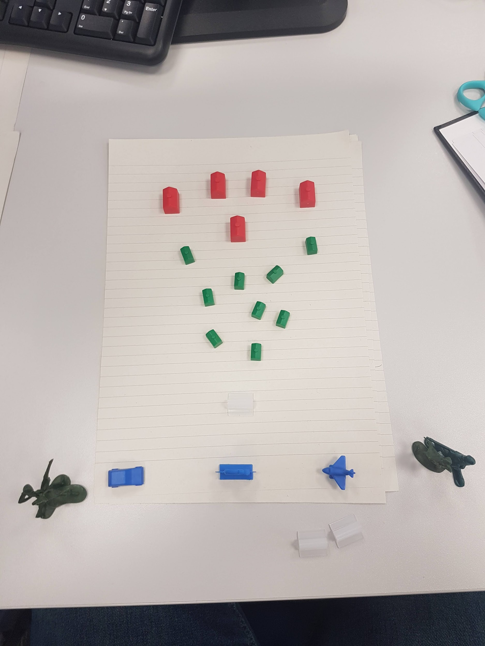After making the initial paper prototype, I decided that this was too simple and limiting, so I expanded this to allow for full player movement around the game world with enemies attacking from multiple directions.

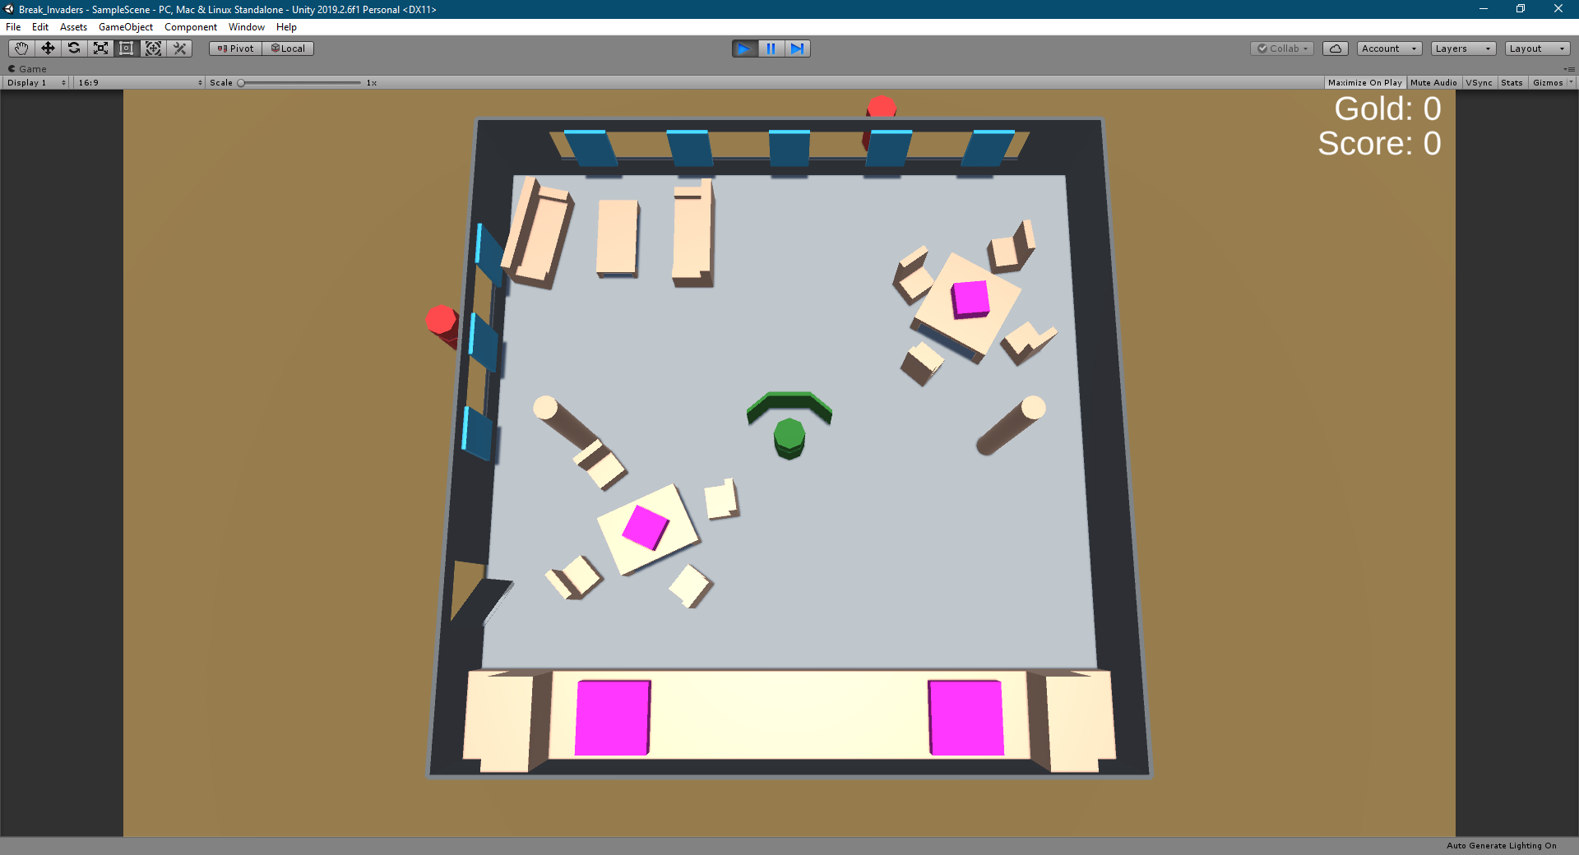

It is set in an office break room in which the player has barricaded themselves into. Hordes of ravenous co-workers are attempting to ruin your lunch-time by destroying the various food items around the room. As such they are throwing masses of office supplies around in the hopes of destruction.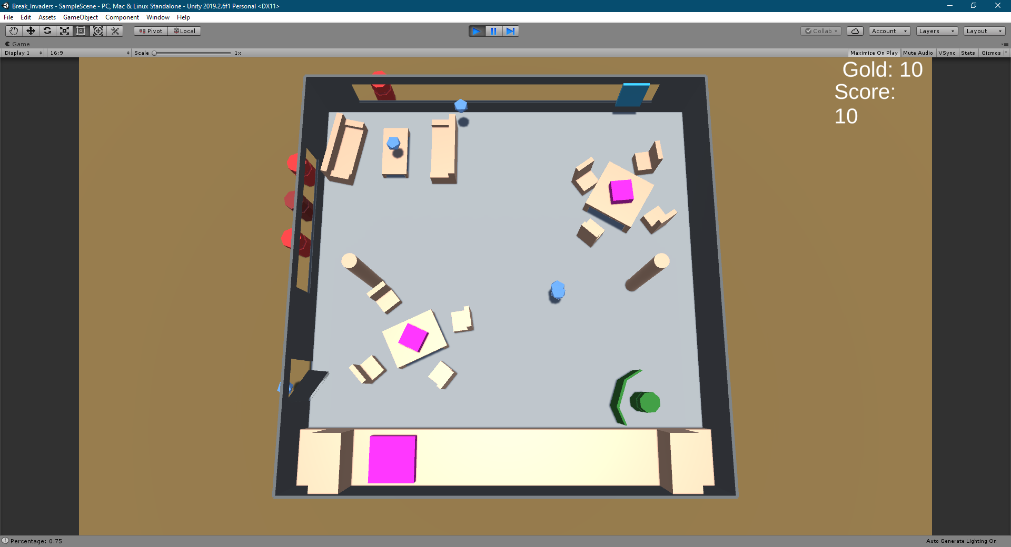

There are three different enemy types each with varying difficulty levels. The clipboard thrower, throws a simple projectile which bounces around the level. The stapler thrower throws a stapler, which upon impact with an object, breaks into multiple staples. Finally, the pencil thrower throws a highly damaging projectile which breaks on first impact. This is slow firing and deadly to ensure they do not overwhelm the player, but still pose a significant threat when spawned.

You must hold them off until the end of the lunch hour where they will return to their work, giving you valuable time to upgrade your defenses and purchase power-ups.

**Mechanics**

* Protect the target - The player must protect a certain amount of targets (in this case food items), from being destroyed by incoming projectiles
* Bouncing Objects - The projectiles bounce around the level according to Unity’s physics system, creating a more intensive playing field, where the player is less able to predict their trajectory, thus making it harder to protect all possible targets, and causing them to prioritise in order to make it through the level successfully, even if it means sacrificing some targets.
* Power-ups - Player can purchase temporary power ups and level upgrades (invulnerability + barricades) in order to help them survive longer during each wave, as well as offer them more options when it comes to prioritising targets. For instance, purchasing barricades in certain areas, can allow the player to protect more exposed targets without having to worry about the now covered ones for a short period of time.

In addition the invulnerability power-up can be timed effectively to avoid mass damage on particular targets giving them a small reprieve and allowing them to more safely reposition themselves.

**Evaluation and Feedback**

**Participants**

Overall, I gathered feedback from a total of four different people over the course of three different testing sessions.

**Feedback**

Please find the feedback logs in the appendix under Prototyping_Feedback.

**Session One - Feedback**

In this session I gathered feedback from three different people. The main pieces of feedback that I received from all participants were centred on the projectile speed being far too quick, and the overall goal of the game being unclear. As such I planned to largely decrease the projectile speed and get further feedback on this in later sessions. I also planned to add a menu system and various UI indicators for aspects such as the main goal, target health and enemy health.

Another important piece of feedback is that the controls were not immediately clear, as such I planned to make either a controls menu, or control indicators as part of the main HUD.

A final piece of feedback from all participants is regarding the level design. They mentioned that they found it far too cluttered and as a result difficult to navigate with size of the player character. As such I planned to edit the level design to make all targets blockable and most paths navigable.

Moving onto less common feedback, one participant mentioned how they found it difficult to tell where and when the enemies would be firing. The former will be fixed with more advanced models showing the direction the enemies are facing, the latter was planned to be solved using a UI indicator to show the charge time for the projectile.

They also mentioned how all the enemies appeared to fire at once, drastically reducing the random element of the game and making it far harder for the player to respond to all threats. This will be solved by slightly randomising the firing cool-down for each enemy spawned.

Another issue people had was finding it harder to distinguish between different projectiles and enemy types. This will be solved once appropriate models have been developed, as the behaviour of each projectile will become much clearer.

One participant mentioned a wish for inverted controls, this should be a simple matter to include.

Finally one participant expressed a wish for the projectiles to reflect of the player’s shield in a more easily predictable manner. He would have preferred that all projectiles get deflected in the direction of the mouse, allowing the player to better control their direction and prioritise enemy targets. However, when presenting this idea to another participant, he believed that this would make the game far too easy, and that he enjoyed the challenge of predicting the angle of reflection of each projectile and how to best align the player’s shield. In light of these conflicting opinions (and preferring the latter), I have opted to not act upon this feedback, and instead spend time improving more unanimously judged areas of the game, another reason for not acting on this feedback is that it would go against one of the core mechanics of “Bouncing Objects”, as in the description it says, you do not have direct control over an object's path, which this mechanic would then give you.

The participant who was against this idea, does however still like the idea of giving the player greater control over the projectiles. However, he feels this should be in the form of power-ups which help to limit this control to brief periods of time. Examples of his ideas are a dash effect, this should be relatively easy to implement and should give the player a wider number options to work with, as the force of the dash would help guide the projectiles move towards the direction of movement. Another power-up he suggested was to allow projectiles to stick to the shield allowing you to fire them at will for a brief period. Whilst this could work, it would require a greater amount of work and would again counter the main mechanic.

**Session Two - Feedback**

In this session I gathered feedback from two different people, one of whom had already given feedback in the first round. Firstly, there seemed to be a slight disconnect between the enemies firing the projectiles and the danger of the projectiles they are firing. To remedy this In plan to scale the enemy model sizes according to their projectile, i.e. pencil thrower will be the biggest, whilst clipboard thrower will be the smallest.

The next issues revolve around the dash mechanic. Participants reported that it seemed largely irrelevant at the moment. The new pencil projectile should help with this as it creates a far greater danger to the targets. This should then force the player to think about rapid repositioning, and therefore make them use the dash more.

They also mentioned that they have no way to know whether their dash ability is ready to use. Therefore I plan to add a UI indicator to show the dash charge level.

Another issue was that the enemies facing is far too random to effectively challenge the player.

One participant wanted a mechanic added that allowed for moveable cover. While this is a decent idea, it is unlikely that there will be enough time to fully implement this system.

The final feedback for this session related to the intelligence of the enemies. One participant mentioned how the enemies should try to avoid sitting behind barricades as this indicates a lack of intelligence. Further to this they feel the enemies should always go to the most optimal firing position available to them, repositioning themselves as new spots become available. I feel this would make the game far too difficult and would completely eliminate and purpose of the barricades. The barricades are there as temporary player upgrades, so if the enemy were to simply avoid them they would be rendering a player choice completely useless. Therefore I am unlikely to implement any changes to the enemy AI.

**Session Three - Feedback**

In this session I only managed to gather feedback from a single person, this person had already given feedback in the first round and therefore already knew how the game was meant to be played.

These changes concern either issues with the UI, player collision and game balancing.

The UI feedback started with the main menu being very basic. This could be remedied with better UI design, or with a more interesting background.

The How-To-Play section was seen to not be up-to-date with the current version of the game. This should be an easy fix however.

Finally the in-game HUD appears to be potentially unclear or cluttered. This could be resolved with better UI design, however I am not very good at this myself.

Moving onto collision issues, there appeared to be an issue where the player could still get caught on environmental objects. I am unsure how to remedy this without drastically changing how the movement mechanics work however.

Another issue is that the shield can occasionally get caught in the top window. Similar to this, if the player purchases a barricade on their current position, they can get stuck as well. These could be remedied by restricting the player’s movement to slightly within the bounds of the wall.

Finally, in regards to game balancing, they remarked that the waves do not appear to get any harder as you go on. This is true at the moment, and so they recommend scaling the difficulty with the wave number with features such as the enemy fire rate, changing the enemy spawn weightings, and gradually increasing the length of each wave. This is all good feedback but may be difficult due to time constraints.

**Final Game**

**Description**

The final game is definitely much improved upon compared to the initial prototype, after three rounds of feedback and other design decisions.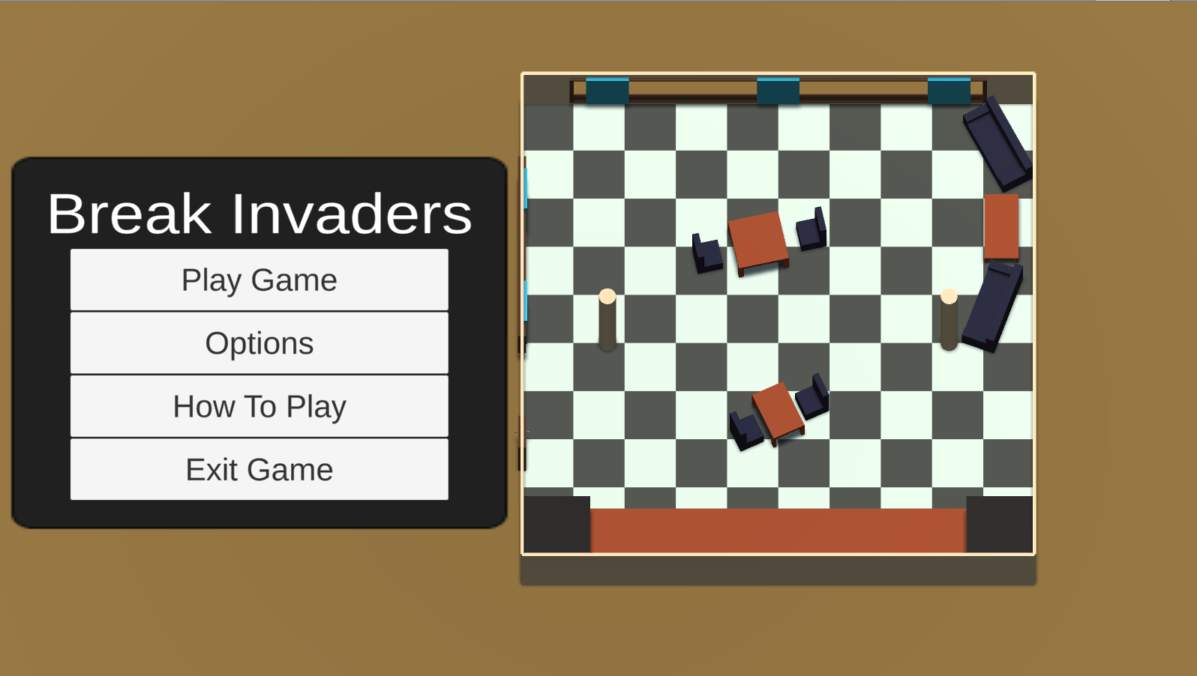

The game in its final form starts you off on the menu screen, from here you can choose to quit, go onto the options screen, look at the control menu or play the game. The options menu presents a single option right now, allowing you to invert the mouse. The control menu gives you a list of the various game inputs as well as a how to play screen. 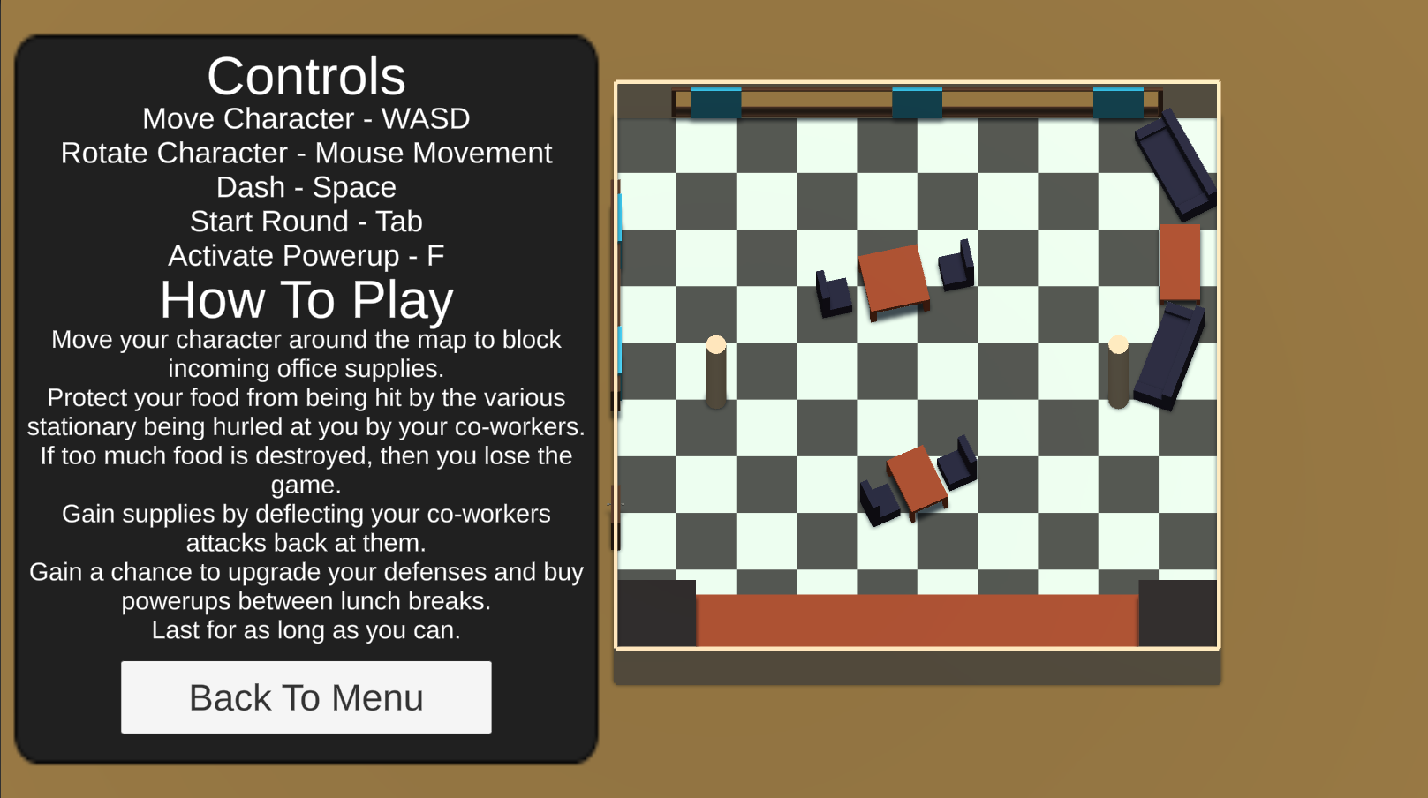

All the menu options have a background image of the game level itself. Upon clicking play, the player is immediately thrown into an active level. The enemies start to spawn and throw projectiles. 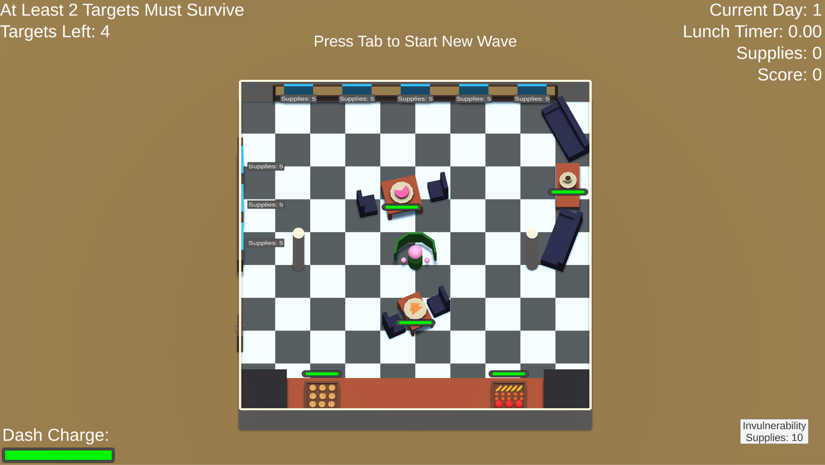

The level starts with a few barricades pre-built to give the player a chance to get their bearings. The player must move around the game level in an attempt to block the projectiles from hitting their food. 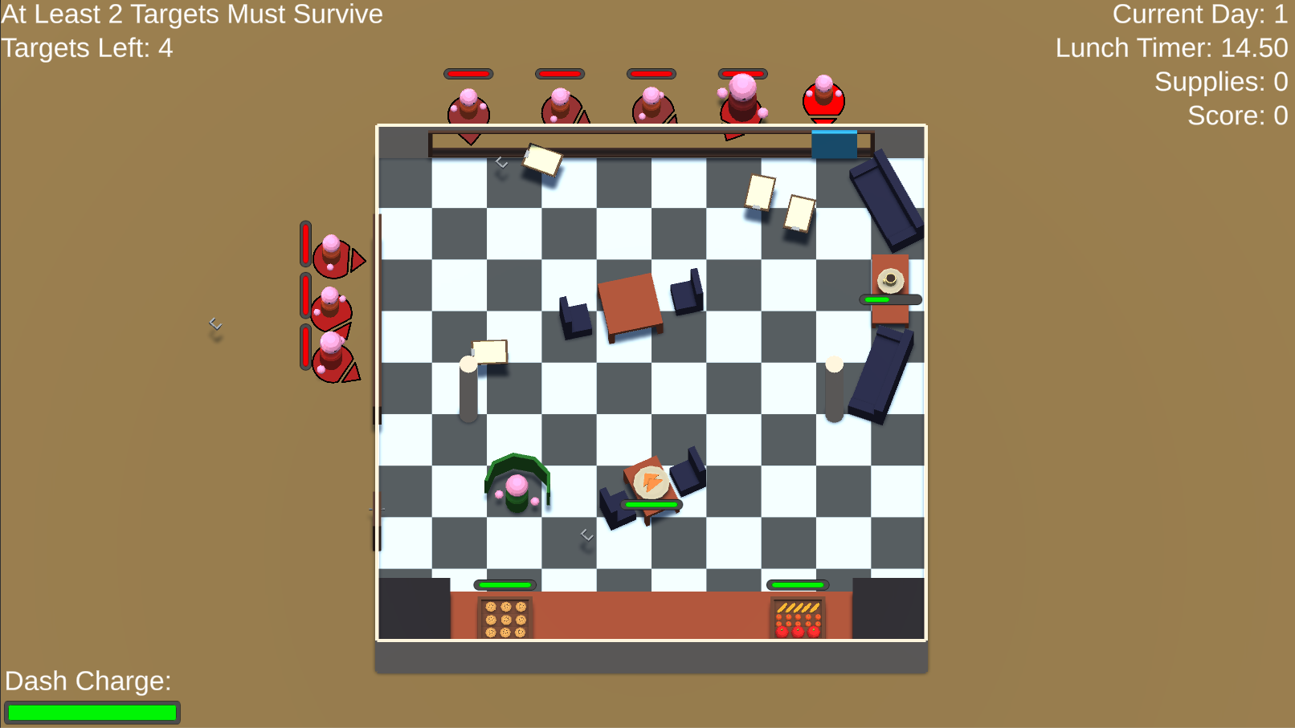As a side objective, the player may choose to try and kill the enemies, both to reduce the incoming fire as well as to gain supplies. Should they survive the wave without losing too many food items, they can choose to buy more barricades as well as a temporary invulnerability power-up. Upon using this power-up, all food items gain temporary invulnerability as shown by a change in the colour of their health bar. This allows the player to reposition themselves without fear of attack. 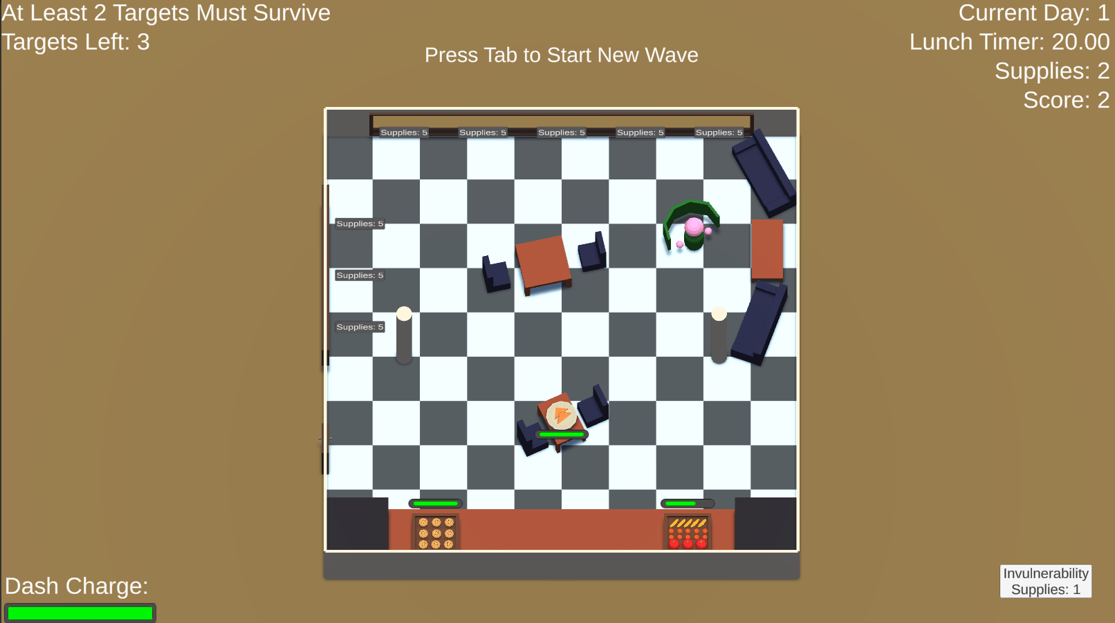The player can also use a dash mechanic to quickly move around the level which has a small cool-down. The game continues until the player finally loses a wave upon which they are presented with their final score and are allowed to return to the main menu.

**Changes from Feedback**

**Session One - Results**

As a result of feedback and ideas for potential improvements the following improvements were made or ignored:

* Projectile speed was reduced to more reasonable levels.
* The level was redesigned. There are more open areas now as well as an extra target, this lets the player move more freely and gives them a chance to protect all targets.
* Main menu was added with sub-menus for options, controls and a how-to-play section. This allows the player a chance to familiarise themselves with the game before being thrown into the actual gameplay.
* Using colour to represent health values would be awkward to implement due to Unity’s system of sharing materials between objects. It makes it hard to edit a material without creating instances, which with the amount of enemies and projectiles would very quickly overwork the system. Therefore I added simple health bars to the enemies and targets, whilst the targets I feel require less feedback now that the models have been added, thereby distinguishing them and giving them a specific purpose.
* I also added a new UI element to the enemies which shows the direction that they are facing in, as well as somewhat indicating when they are about to fire. This gives the player the ability to counter the enemies as they have more information as to what is happening in the game.
* The enemies now have a slightly random fire delay to reduce the chance of them firing all at the same time.
* An inverted mouse option was added, found in the new options menu off of the main menu.
* The spawning issues with the enemies was fixed so that they do not stack upon one another thereby making it clearer who is firing what. Also new projectile models were added to help distinguish between projectile types and effects.
* The sticky ball power-up was not implemented due to reasons stated above. The speed push or Dash however was implemented, allowing the player to occasionally use Space for a small burst of speed.
* I did not alter the way the shield reflection works due to reasons stated in the feedback section.

**Session Two - Results**

As a result of feedback and ideas for potential improvements the following improvements were made or ignored:

* The enemies are now scaled according to their projectile danger.
* More dangerous projectiles were added to force the player to reposition more rapidly.
* A charge bar was added to the lower left HUD to indicate the dash mechanics readiness.
* Enemies now face vaguely towards a random target, Pencil throwers do this with zero variation to ensure their attacks are lethal.
* All other recommendations were left unimplemented either due to time constraints or design differences indicated in the feedback section.

**Session Three - Results**

As a result of feedback and ideas for potential improvements the following improvements were made or ignored:

* The main menu was given a more interesting background, showing the game level.
* The controls menu was updated to reflect all new changes such as the wave system and the upgrade system.
* The in-game UI was not updated due to time constraints and a general lack of UI design skills on my part.
* Player collision with the furniture remains unresolved due to time constraints preventing a movement mechanic overhaul.
* While scaling difficulty would have been very useful I unfortunately did not have time to implement this by the deadline.

**Quality of Gameplay**

In regards to how the game feels, I will start by analysing the method of input. At present, the game is controlled by using the keyboard and mouse. Given further time, I believe I would make it suitable for controller use instead both for nicer gameplay as well as player feedback. It would have been nice to give haptic feedback upon targets being hit for instance. More importantly, I’ve had my game described as a twin-stick shooter in its control style, so making it actually use the appropriate controller would likely make it more intuitive. Regarding the control scheme as it is, I believe that the controls are well mapped. The use of the mouse for rotation gives the player a better sense of where they will be facing and the use of WASD is very conventional for movement and easy to adopt.

Thinking about how the game plays, I feel that the overall level design allows for an appropriate amount of variations regarding projectile bouncing to make for novel experiences.

The general visual style is quite simplistic as to not unnecessarily overcomplicate the players view. Keeping to low-poly models helps draw the player’s attention to the more important aspects of the game, mainly through the use of colour, for example, the player character is coloured bright green, the enemies varying shades of red and the targets are also quite vibrant colours in comparison to the background which uses otherwise muted tones.

In relation to the main mechanics the game uses the visual style as well as verbal instruction to inform the player. For instance, the main controls are outlined through the controls menu, however as the player gets further in the game they begin to learn how the enemies act, as well as how each of the various projectiles work. The model for the pencil projectile would indicate a lack of bounciness and a certain piercing quality, this along with its rarity should help inform the player of the potential damage it could deal. The stapler, whilst not immediately obvious, is known for containing multiple smaller objects. Upon the player’s first sight of how this interacts with the world, they soon learn that it is intended to break apart to release what it contains.

In regards to sound design, the background music is intended to supply a calming and relaxing air over what is otherwise a chaotic battlefield. It is intended to indicate what the office should be like as opposed to what is actually happening, potentially providing some comedic relief from the game. The sound effects are more descriptive for what is actually happening, and were chosen to only represent certain interactions within the game world. For instance, if a sound were to play on every projectile bounce, it would quickly become overwhelming. Limiting the sound effects to only damaging hits helps to give greater impact to these noises, and varying the sounds between the target types e.g. food or enemy should help the player better distinguish what has occurred elsewhere on the game field.

**Critique**

For my critique I analysed and gave feedback on the initial prototype of Chris Ross.

**Mechanics**

The core mechanics this prototype is meant to combine are as follows:

* Running and Jumping
* Timed
* Avoiding Un-killable Objects

He combines these mechanics effectively, and in the case of the Timed mechanic, quite subtly through the use of a limited light source.

**Assessment and Improvements**

Overall, I found that I enjoyed his game and how it felt. The controls felt smooth and responsive. The procedurally generated platforms were well-placed and offered me a good level of challenge, whilst always remaining possible.

The most impressive part of his game at this point is the aesthetic. The sound design is very well done, as is the general art style. I particularly liked the death screen, and the Dark Souls (*FromSoftware, 2011*) vibes I got from it, using such an aesthetic really helps to give greater impact to the player’s death and is therefore well used.

There are also a number of areas which I feel could have been better. The first is that the water level rose far too quickly for my liking, and by the time I was aware of this as a mechanic, it was already too late to avoid it. Therefore I would recommend he scale the water’s speed with the player’s progress through the game.

In addition, I found a number of issues regarding the starting area of his game. The first is that it is unclear which direction the player must initially travel in. This means that the player wastes valuable time when they pick the wrong direction, which can be critical to survival later on. I would therefore, either clearly indicate the intended direction with either closer platforms or a clear light source, or ensure that the first platform is always to the player’s left, to fit with convention. Another issue with the player’s spawn is how close the initial plants are. These plants damage the player when they collide with them, and with the close proximity, it is highly likely that the player will hit them without knowing. Whilst this could be considered a teaching method, it can also be rather frustrating and unnecessary. I would therefore increase the distance between the initial plants and the player’s spawn point, to give them a better chance to react and let the plants visual style indicate its danger.

Another issue I found with environmental hazards was the length of time that the water spout effect affected you. This greatly limited player vision and was rather annoying. In order to counter this, I would either reduce the timer on this effect or otherwise minimise the impact of it.

A final piece of criticism concerns the lighting system he uses. At the moment there is no feedback to alert the player as to when the light source is going to run out. This prevents the player from trying to find another light source in time and leaves them literally stranded in the darkness, with no way of progressing. I would therefore add a slight flicker to the light as it starts to run out to alert the player to this.

Despite these improvements, I still enjoyed my first run-through of his game and could see myself getting more absorbed by it, should the points of frustration be eliminated.

**Production log**

Please see WeeklyLog In the appendix.

**References**

*Atari (1976) Breakout. [Arcade] Arcade Cabinets. Paris:Atari Inc.*

*Taito (1978) Space Invaders [Arcade] Taito 8080. Tokyo: Taito.*

*From Software (2011) Dark Souls [DVD] PS3. Tokyo: Bandai Namco Entertainment*

*Joth (2016) Bossa Nova [Music]. Accessible from:* [*https://opengameart.org/content/bossa-nova*](https://opengameart.org/content/bossa-nova)

*MidiPixel (2019) BlendWave [Website]. Accessible from:* [*https://beta.blendwave.net/?p=wavePanel*](https://beta.blendwave.net/?p=wavePanel)

**Appendix**

Production Log - WeeklyLog.docx.pdf

Feedback Logs - Prototyping_Feedback.pdf